**Task 5 Reading Guide**

**Calculating Expected Return**

* The return between two periods is typically calculated using a standard percentage change formula:
  + % Return (Period 1) = (Price1 / Price0) – 1
* In the first part of this task, you will calculate the Expected Return for each fund using an average (mean) formula.
  + Under this method, expected returns are informed by the historical returns profile for simplicity.
  + For instance, if Fund A generated returns of 5% in 2018, 10% in 2019 and 15% in 2020, the expected return for 2021 would be AVERAGE(5%, 10%, 15%) = 10%.
* In the second part of this task, you will also calculate the Expected Return for the Portfolio.
  + This can then be calculated by using the weightings of each fund and the average returns of each fund:
    - Portfolio Return = Return1 x Weight1 + Return2 x Weight2 + ……. + Return8 x Weight8
  + Alternatively, you can use the SUMPRODUCT formula:
    - Portfolio Return = SUMPRODUCT(Row of Mean Returns, Row of % Allocation in Portfolio)

**Recap: Standard Deviation and Variance**

* Two of the most common ways to measure risk in investing are standard deviation and variance.
* The standard deviation and variance of a data set measures the dispersion of returns from their average return (i.e. the spread of annual returns from their average return).
* Consider this example:
  + Facebook has generated returns over the last 5 years of:
    - Y1: 12%
    - Y2: 5%
    - Y3: (2%)
    - Y4: 10%
    - Y5: 20%
  + The average (mean) return is 9%.
  + The deviations from the mean for each year are:
    - Y1: 3%
    - Y2: (4%)
    - Y3: (11%)
    - Y4: 1%
    - Y5: 11%
  + The sum of the deviations always equals to zero (by virtue of how the mean is calculated).
* Therefore, a useful measure of dispersion is to calculate variance.
* Variance is the sum of squared deviations divided by the one less than the number of observations (sample method):
  + Y1: 3%2 = 0.09%
  + Y1: (4%)2 = 0.16%
  + Y1: (11%)2 = 1.21%
  + Y1: 1%2 = 0.01%
  + Y5: 11%2 = 1.21%
  + Sum = 2.68%
  + Divided by Number of Observations less 1 = 2.68% / 4
  + Variance = 0.67%
* To calculate the standard deviation, take the square root of the variance:
  + SQRT (0.67%) = 8.19%
* High standard deviations and variances indicate high volatility in returns, and hence a riskier investment. Conversely, lower standard deviations and variances indicate low volatility in returns, and hence represent a less risky investment.

**Quantifying Portfolio Risk**

* To calculate the risk for a Portfolio of multiple assets (in this case multiple funds), you need to take into account:
  + **(A)** Weighting of each fund present in the portfolio
  + **(B)** Variance of each fund present in the portfolio
  + **(C)** Co-variance of each fund with every other fund present in the portfolio (i.e. how similar are the value movements between the funds from one time period to the next)
* For **(C)**, we need to create a *co-variance matrix*, which is essentially a grid that demonstrates the relationship (co-variance) of each fund with every other fund under consideration.
  + For instance, in the example below, there are three funds under consideration

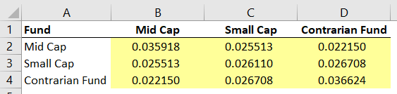

* + The formula to calculate co-variance between two funds (i.e. the values in the yellow cells) is:
    - **= COVARIANCE.S (Fund 1’s returns column, Fund 2’s returns column)**
    - For instance, if calculating Mid Cap’s co-variance with Small Cap, the formula would be   
      = COVARIANCE.S (B2:B8, C2:C8)

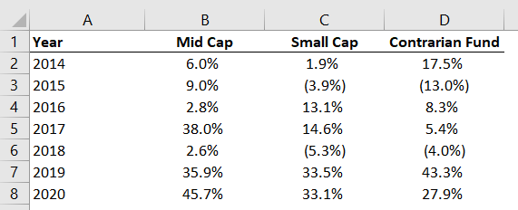

* Once the co-variance matrix is completed, *the variance for each fund* can be calculated using
  + Each fund’s weighting %;
  + The co-variance matrix;
  + The % weighting of every other fund in the portfolio.
* Given the technicalities involved are beyond the scope of the task, this last calculation has been completed for you within the Excel file for this task. You can review it in Row 49 of the “Portfolio Optimisation” sheet
* Thereafter, the *Portfolio Variance* is then simply the sum of the variances of the funds in the portfolio.
  + To calculate the standard deviation of the portfolio, as with a single asset, take the square root of the portfolio’s variance

**Sharpe Ratio**

* In this exercise, we are using the Sharpe Ratio as our measure of risk-adjusted return
* The Sharpe Ratio measures an investment's return after accounting for the level of risk that was taken to achieve it. It measures the “expected excess return per unit of risk”
* When comparing two investments against the same benchmark (in this case the risk-free rate is the 10 Year US Treasury Yield), the asset with the higher Sharpe ratio provides a higher return for the same amount of risk, or the same return for a lower risk than the other asset
* *When comparing two different investments against the same benchmark, the asset with the higher Sharpe ratio provides a higher return once adjusted for the same amount of risk*